**CSU Antenna Test Range – Physical Functional Evaluation**

Adam Hulse

Department of Electrical and Computer Engineering, Colorado State University

Dr. Branislav Notaros

September 8, 2022

*Overview*

In the initial functional evaluation of CSU’s Antenna Test Range, a variety of aspects were inspected and tested. Some of which included testing the scans of the six different axes of freedom and verifying the radiation pattern matches that of a horn antenna. From these results, it is determined if any action is required. If the radiation pattern looks correct, then no further action is required, if the radiation pattern does not look correct, then further action to correct the issue is needed. And in the case of one of the axes of freedom, it does not even operate, further action is absolutely required. Note that all readings were taken with a resolution of 0.25.

After the meeting with Ball Aerospace on Friday, September 16, 2022, some of further actions decided will come from their personal range managers (Carlos Arzola) recommendations. During the meeting, some of the results of the functional evaluation was brought up and possible causations were determined. These will be further discussed later when going over each of the scans.

*Scan Results*

**Depth**

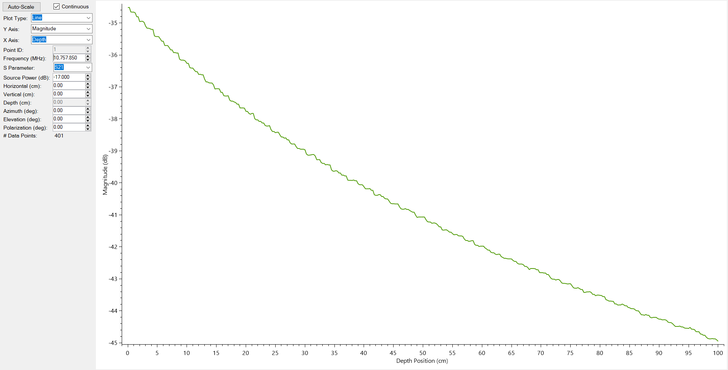

*Figure 1:* Radiation pattern from depth scan from ~15cm to 115cm from aperture to aperture.

Based on the results seen in Figure 1, the depth scan does show a decay of what appears to be $\frac{1}{d^{2}}$ where *d* is the distance from aperture to aperture. The plot shows the magnitude of the power and power decreases proportionally to $\frac{1}{r^{2}}$ which is why this plot shows a good reading. There will be no further action needed with the depth axis of freedom.

**Elevation**

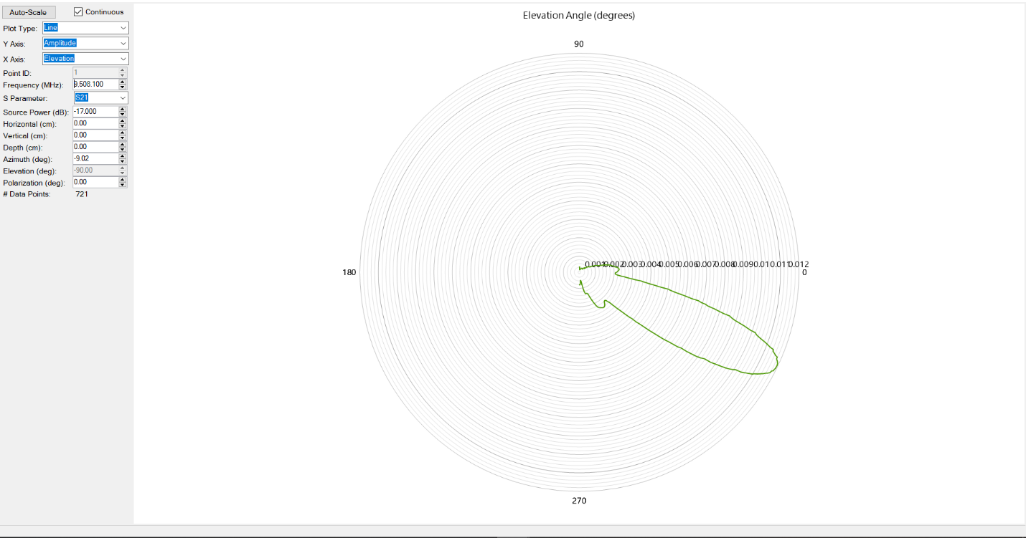

*Figure 2:* Radiation pattern from elevation scan from $-180°≤θ≤0°$.

Based on the results of the elevation scan, the actual pattern does look correct and smooth. This is the look that was looked for, so the overall shape of the radiation pattern is correct. However, the actual angle which it shows the max, is not correct. But this could be due to a zeroing error, so further action of investigating the software side could potentially fix this. Or, forgetting to set all coordinates to zero before setting the elevation to $-180°$ could also play an affect on the actual positioning of the plot.

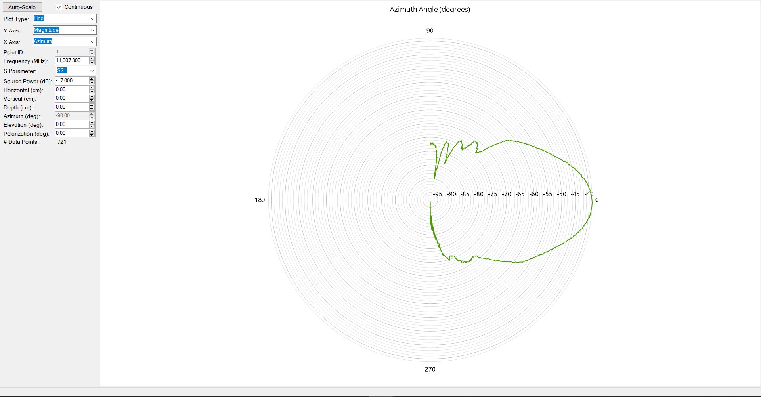**Azimuth**

*Figure 3:* Radiation pattern from azimuth scan from $-90°≤ϕ≤90°$.

Based on the results of the azimuth scan, this does have a relatively correct shape. However, when Carlos was looking at the test range, he made a critical discovery of noticing that the aperture of the antenna is *not* directly above the axis rotation. So, the actual scan is of the antenna making an arc around $ϕ$ with a radius of roughly 9 – 10cm, which this is why the main lobe so wide. This is a very large problem because that will mean any reading that involves a $ϕ$ component will not give an accurate reading. This problem is one that needs to be resolved as soon as possible and is already in the works. The solution is to design and manufacture a new mount to hold the antenna which will provide an offset to center the aperture at the axis of rotation.

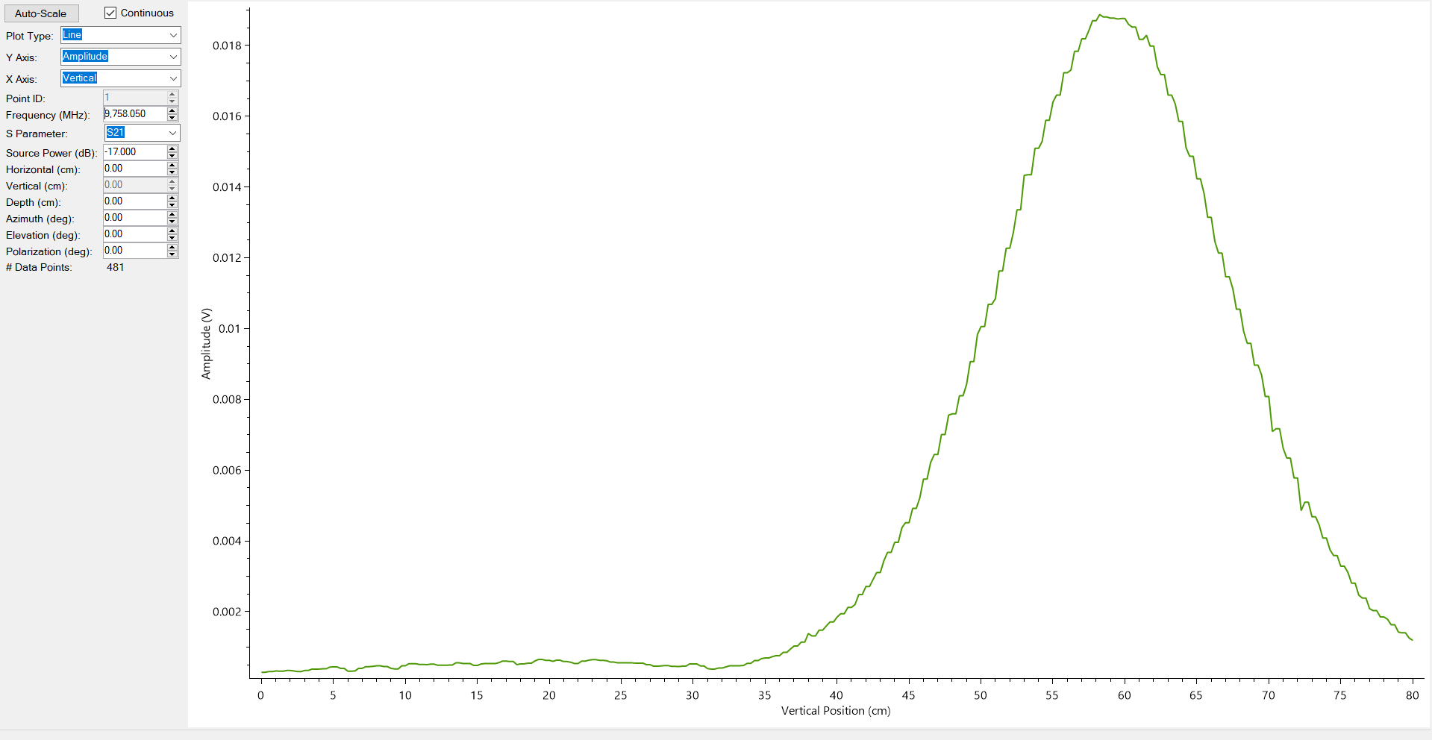**Vertical**

*Figure 4:* Radiation pattern from vertical scan from 0 to 80 cm with center at 40 cm.

Based on the results from the vertical scan, the pattern does look correct with having a peak. However, the peak is not at the 40 cm mark which is where the peak should be since both antennas will be in direct line of each other. This is again an issue that can possibly be due to calibration in the software and will need to be investigated further.

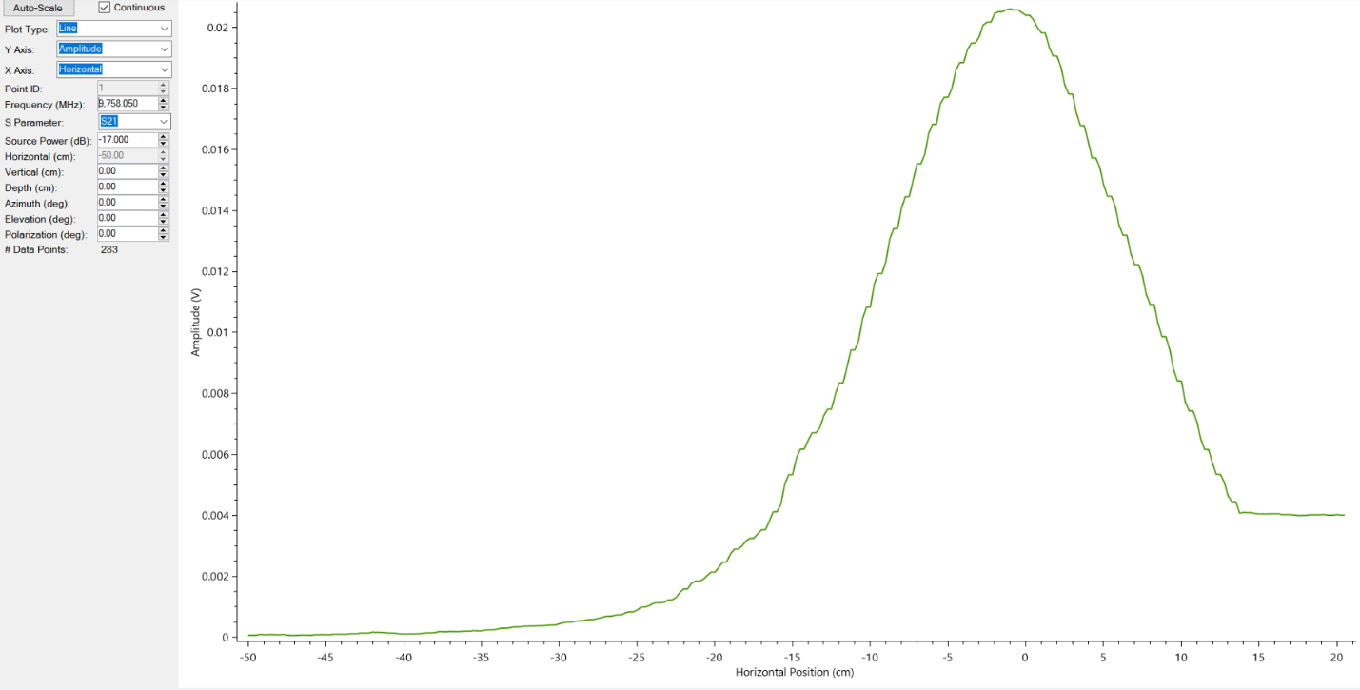**Horizontal**

*Figure 5:* Radiation pattern from vertical scan from -50 to 50 cm with center at 0 cm.

Based on the results of the scan of the horizontal direction, the scan looks very good with the peak of the scan centering at ~0 cm. At first glance, the plot does flatline around the 13cm marks, but after investigating this issue, it was found that a wire had gotten on the rail and was prohibiting the mechanism from moving. This issue has been resolved and the wires have been tied up and out of the way so they will not interfere with the movement.

**Polarization**

The polarization scan was not able to be performed and this is because the motor is not engaging when then system is turned on. This needs to be fixed immediately and is in the works to determine why it is not engaging. There could be two reasons why it could not be working, and it is that it is not receiving power, or it is burned up and needs to be replaced. The 2021/2022 team did have an issue with the motor overheating and applied a heatsink to it to mitigate the temperature. However, there is a chance that the motor has still been burned up.

After investigation, it appears the motor has been burnt up, it is receiving power, but it is not engaging. So, a new motor will need to be order and likely calibrated so that it is accurate. There is no documentation on this specific motor because the motor that is controlling the elevation is a different motor.

**Conclusion**

The functional evaluation in the end did show good results with many of the plots looking correct and in the case of two of them, knowing why they don’t quite look correct. And the case of the polarization motor, it is known that it needs to be fixed and will be investigated further to determine the plan of action to correct it. However, for the other issues, plans of action have already been set in place and will be worked on throughout the semester to improve the overall accuracy of the test range and even give smoother plots.